** ACTIVE TOUR TO BAIKAL WITH TREKKING**





**5 days / 4 nights**

**OLTA Travel**

**Guaranteed departures**

**June – August 2020**

**Day 1) Irkutsk, Listvyanka**

* ARRIVAL AT THE AIRPORT
* MEETING WITH ENGLISH-SPEAKING GUIDE
* BREAKFAST AT THE RESTAURANT

**CITY TOUR**

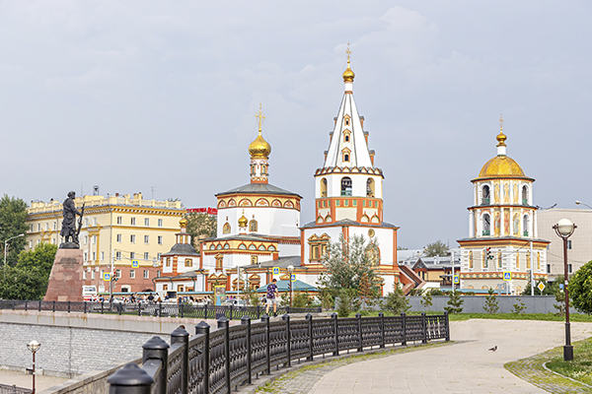Get ready to explore a centuries-old Siberian merchant center! You will see the remains of the fortress Irkutsk including the Spasskaya Church, which was part of Irkutsk Kremlin. As the stronghold grew, merchants were coming here to settle and trade riches of Siberia — mainly furs. The fancy designs of their wooden homes will help you feel the spirit of the time. Your journey through centuries will take you to the house where Decembrists, Russian noble rebels lived in exile, a beautiful gingerbread-like 19th-century building of the History Museum and further, to the memorial grave of Alexander Kolchak, the legendary general of the Russian Civil War.

**TALTSY MUSEUM**

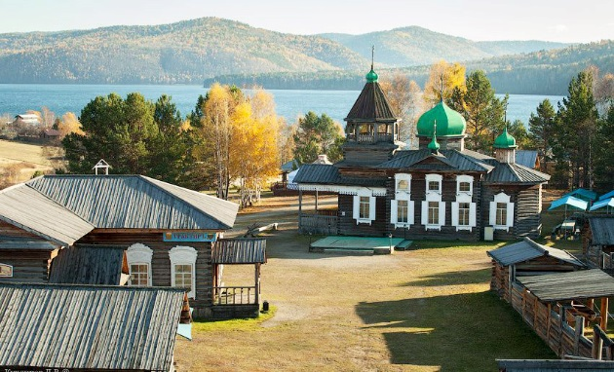Until the mid-20th century, both Russians and Siberian native tribes produced wooden architecture. Irkutsk managed to preserve this heritage at Taltsy, a unique open-air museum. Once you step in, you completely forget about modern life. The fascinating 17th-century fortress towers and authentic huts invite you to explore the history of the region first-hand. Don’t pass up the chance to get inside one of these fancy homes and see the authentic way of Siberian living with your own eyes! If you want to immerse yourself even more deeply into the original ethnic culture, you can attend traditional craft workshops and unforgettable performances at the museum.

* FREE TIME FOR LUNCH
* TRANSFER: IRKUTSK - LISTVYANKA
* CHECK-IN AT THE HOTEL
* DINNER AT THE RESTAURANT
* OVERNIGHT IN THE HOTEL

**Day 2) Listvyanka, Bolshie Koty**

* BREAKFAST AT THE HOTEL
* CHECK-OUT OF THE HOTEL
* MEETING WITH ENGLISH-SPEAKING GUIDE
* DINNER AT THE HOTEL

**RUSSIAN BANYA**

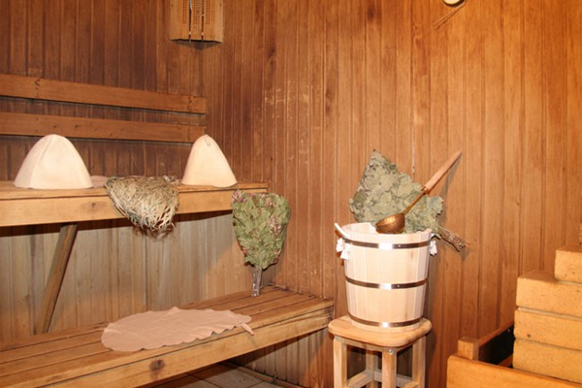When visiting Russia, make sure you experience one of the oldest national traditions known as banya. Back in the 10th century, the bathing ritual, enjoyed by peasants and nobles alike, fascinated travelers from abroad. For centuries, you could not imagine a decent Russian house without a banya. Nowadays, friends, colleagues, and family often meet at a banya to relax and discuss a range of topics, from personal matters to business problems and even political issues. We invite you to bathe like a Russian!

* OVERNIGHT IN THE HOTEL

**Day 3) Bolshie Koty, Listvyanka**

* BREAKFAST AT THE HOTEL

**TREKKING TO THE SKRIPER ROCK WITH LUNCH**

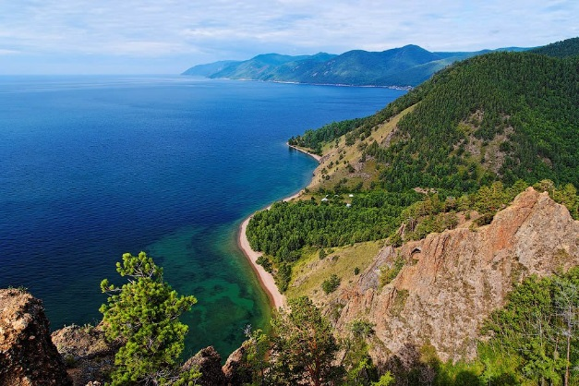Skriper is a rocky cape, located on the West coast of the Baikal Lake 4 km from the village Bolshie Koty. The cliff is composed of a rare rock that forms its picturesque slopes. Having risen to a height of 200 meters you will see a cave of about 60 square meters, where were found the traces of an ancient man: tools, fragments of clay utensils and traces of fires. In addition, getting to the top, you will have a great pleasure watching the breathtaking view of Lake Baikal, and tasting a delicious lunch.

* **TRANSFER BY BOAT FROM BOLSHIE KOTY TO LISTVYANKA**
* CHECK-IN AT THE HOTEL
* DINNER AT THE HOTEL
* OVERNIGHT IN THE HOTEL

**Day 4) Listvyanka**

* BREAKFAST AT THE HOTEL

**CRUISE TO CIRCUM-BAIKAL RAILWAY WITH LUNCH (5 HOURS)**

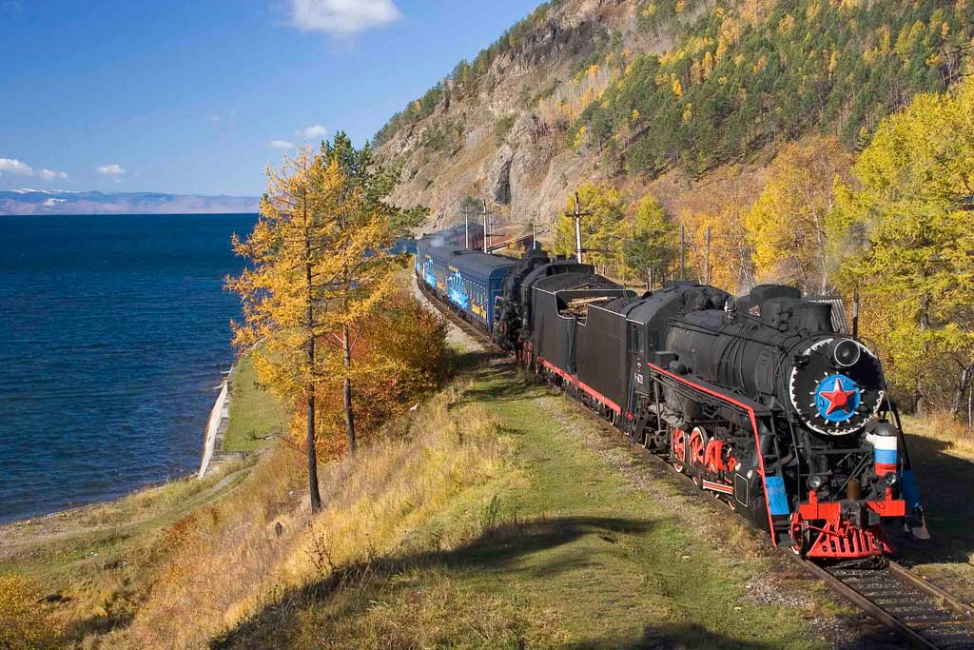Let’s explore Baikal by following the old routes! We invite you for a cruise along the Circum-Baikal Railway which is known as one of the world’s most beautiful and sophisticated railroads. Its every kilometer is a result of construction work as complex as no other railway has ever seen. You will see century-old stations, bridges, tunnels and magnificent stone galleries. Not to mention the stunning views of Baikal from its southeastern shore! It will be a long tour, so we have already taken care of your lunch.

* FREE TIME FOR DINNER
* OVERNIGHT IN THE HOTEL

**Day 5) Listvyanka**

* BREAKFAST AT THE HOTEL
* CHECK-OUT OF THE HOTEL
* DEPARTURE FROM THE AIRPORT
* TRANSFER: LISTVYANKA - IRKUTSK

The order of the visits might be changed. However, all visits mentioned in the program will be provided in full.

**NET PRICE PER PERSON PER PACKAGE, IN ½ DBL, IN EUR\***

5 days / 4 nights

|  |  |  |
| --- | --- | --- |
| **Dates** | **Based on Hotel 3* "Nikola" in Listvyanka or similar and Hotel "Guest House" 3* in Bolshie Koty or similar and Hotel 3* "Marks" in Irkutsk or similar** | |
| **½ DBL** | **SGL SUP.** |
| **14 - 18 June 2020** | 590€ | 122€ |
| **18 - 22 July 2020** |
| **16 - 20 August 2020** |

* All rates are subject to change in case of EUR/RUR exchange rates fluctuations more than 5% compared to the official Russian Central Bank rate established on 31.10.2019 unless deposit or full payment is already done.

|  |  |  |
| --- | --- | --- |
| **Price includes** | | **Price does not include** |
| * 4 nights in hotels * Transport services as per the program * English-speaking guide services as per the program * Meals as per program * Entrance fee as per the program * Visa support letter (scan) if required | * Tips * Photo and video shooting tickets * Meals and beverages except mentioned * Russian visa fees * DHL delivery service * Flights * Options | |