**Olta Travel tour**

**Adventures in Sochi**

**4 days**

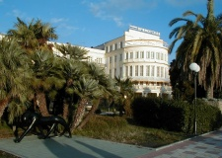

**Short program:**

* Day 1: Arrival in Sochi.
* Day 2: Panoramic **city tour**. Visit **Tea Houses** and tea plantations.
* Day 3: Excursion to **MATSESTA curative springs**. Excursion: **Stalin’s Dacha**.
* Day 4: Visit to **Sochi Olympic park**. Transfer from the hotel to the airport.

**Day 1: Sochi**

* Arrival in Sochi.
* Meeting at the airport with an English-speaking guide.
* 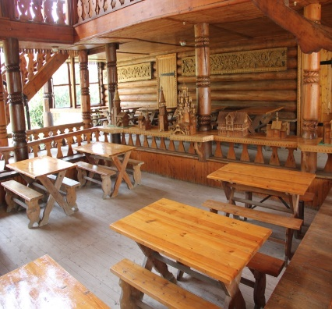Transfer to the hotel.

**Day 2: Sochi**

* **Panoramic city tour**.

During the tour you will see the city’s main highlights, including the **Pushkinskaya Library, the Canon and Anchor monument**, the Primorskaya Hotel – one of the oldest hotels in the city, built in the 1930s in Stalin’s Empire style; and the **Winter Theatre** – another majestic example of Stalinist architecture.

* **Tea Houses, tea plantations**.

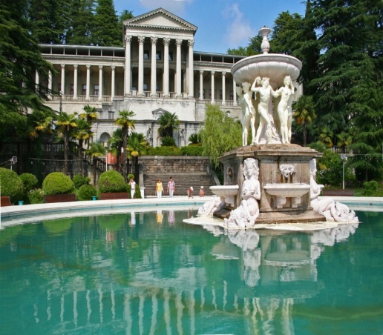**Dagomys** - the place truly unique. Located in the village Lazarevskiy, 12 km from the center of Sochi. The most northerly tea in the world is grown and cultivated in Sochi, between Looe and Dagomys on a high hill in the **village of Uch-Dere**. There are tea houses, where you can taste the Russian tea. Amazing beauty sites, a **little museum, tea with honey and pies** - that's what awaits you there.

**Day 3: Sochi**

* **Excursion to Matsesta curative springs.**

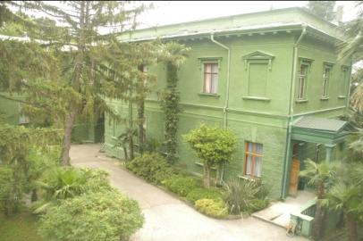Located southeast of the port near the Matsesta River, the springs that provide the hydrogen sulfide waters at the **Matsesta Spa** were known by Roman colonists in the area who believed as many still do that the waters have medicinal and recuperative effects. The current spa was developed starting in 1902 and the building and its vicinity include caves, scenic walks and the **neo-classical** building which are part of the tour that is offered here.

* **Excursion: Stalin’s Dacha.**

On the top of the mountain range between Matsestinskaya Valley and Agura Canyon there is a **mysterious green castle**. It is Josef Stalin’s former dacha that is surrounded by beautiful **forest-park**, which is now considered to be the most prominent **monument of nature on the Black Sea coast**…

**Day 4: Sochi**

* Excursion to the **Sochi Olympic Park**.
* Transfer from the hotel to the airport.

**Price upon the request**

|  |  |
| --- | --- |
| **\*Offer includes:** | **\*Offer doesn’t include:** |
| * Accommodation for 3 nights in Marins Park hotel or similar 4*; * Bus services as per the program; * Professional guide services (European languages) as per the program; * Entrances as per the program. | * Tips; * Photo and video shooting tickets in Museums; * Russian visa fees; * Meals & Beverages; * Porterage; * Flight tickets; * Optional. |

*All rates are subject to change in case of EUR(USD)/RUR exchange rates fluctuations more than 10% compared to the official Russian Central Bank rate established on 11.11.2014 unless deposit or full payment is already done.